Football Matches Data Analytics

Prakhar Sachan
School of Computer Science and Engineering
Vellore Institute of Technology
Chennai, India
prakhar.sachan2020a@vitstudent.ac.in
Raman Kumar
School of Computer Science and Engineering
Vellore Institute of Technology
Chennai, India
raman.kumar2020@vitstudent.ac.in
Deepansh Tripathi
School of Computer Science and Engineering
Vellore Institute of Technology
Chennai, India
deepansh.tripathi2020@vitstudent.ac

Abstract— The goal of this project is to develop a prediction system that can accurately predict whether a home team will win or not in a football match. We will use four different machine learning algorithms-SVM, Logistic Regression, Random Forest, and XGBoost to develop our prediction system. We will use a dataset of past football matches with associated outcomes to train and test our models.
The dataset contains various features such as the team names, the date of the match, the venue, and various statistics related to the teams and their players. We will pre-process the data and perform feature engineering to extract relevant features that can help us predict the outcome of a match.
We will then train our models using the pre-processed data and evaluate their performance using various metrics such as accuracy, precision, recall, F1 score, and area under the curve (AUC). We will also perform a statistical analysis to determine the significance of the results. The model with the best performance on the test dataset will be selected as the final model for our prediction system.
The prediction system can be used by sports enthusiasts, fans, and gamblers to make informed decisions about placing bets on future football matches. Our prediction system can also be extended to other sports and used for various applications such as player selection, team composition, and strategy development.
Keywords—SVM, XGBoost, F1Score, Prediction.

Introduction
Sports betting has always been a popular activity for fans, enthusiasts, and gamblers alike. The thrill of predicting the outcome of a match and the possibility of winning a considerable amount of money make sports betting an exciting and enjoyable pastime for many. However, predicting the outcome of a match is not always straightforward, as there are many factors that can influence the final result. Therefore, the development of prediction systems that can accurately forecast the outcome of a match has gained significant attention in recent years. In this project, we will focus on developing a prediction system that can determine whether a home team will win or not in a football match.
Football is the most popular sport worldwide, and predicting the outcome of a match is a challenging task due to various factors such as team composition, player injuries, home advantage, etc. Therefore, we will use four popular machine learning algorithms to develop a prediction system that can predict whether a home team will win its match or not. We will use the following four algorithms for this purpose: support vector machines (SVM), logistic regression, random forest, and XGBoost. These algorithms are commonly used in machine learning and have been shown to provide accurate predictions for various tasks.

- Dataset contents
Sl. No. | Column names | Details
1. | Div | League Division
2. | Date | Match Date (dd/mm/yy)
3. | HomeTeam | HomeTeam
4. | AwayTeam | AwayTeam
5. | FTHG | Full Time Home Team Goals
6. | FTAG | Full-Time Away Team Goals
7. | FTR | Full-Time Result (H=Home Win, D=Draw, A=Away Win)
8. | HTHG | Half Time Home Team Goals
9. | HTAG | Half Time Away Team Goals
10. | HTR | Half Time Result (H=Home Win, D=Draw, A=Away Win)
11. | Attendance | Crowd Attendance
12. | Referee | Match Referee
13. | HS | Home Team Shots
14. | AS | Away Team Shots
15. | HST | Home Team Shots on Target
16. | AST | Away Team Shots on Target
17. | HHW | Home Team Hit Woodwork
18. | AHW | Away Team Hit Woodwork
19. | HC | Home Team Corners
20. | AC | Away Team Corners
21. | HF | Home Team Fouls Committed
22. | AF | Away Team Fouls Committed
23. | HFKC | Home Team Free Kicks Conceded
24. | AFKC | Away Team Free Kicks Conceded
25. | HO | Home Team Offsides
26. | AO | Away Team Offsides
27. | HY | Home Team Yellow Cards
28. | AY | Away Team Yellow Cards
29. | HR | Home Team Red Cards
30. | AR | Away Team Red Cards

Literature review
Many studies have been conducted to improve the accuracy of football match prediction criteria. The subsequent research was conducted to identify an optimal model for the forecasting of football matches.
Alfredo et al. [1] studied the prediction of football matches utilising tree-based model techniques including C5.0, random forest, and extreme gradient boosting. The backward wrapper approach was employed as a feature selection methodology to help choose the optimal feature to increase the model's accuracy. This study analysed 10 seasons of EPL football matches and 15 starting characteristics to predict match outcomes (home win, away win or draw). The random forest method produced the most accuracy, 68.55 percent, while the C5.0 algorithm produced the lowest accuracy, 64.87 percent, and the extreme gradient boosting technique produced 67.89 percent accuracy.
Sathe et al. [2] created a dataset to predict the outcome (home win, away win, or draw) of EPL matches by web crawling team ratings from sofifa and taking into account the performance of each team on home and away fields. Each team's FIFA rating and performance over the previous ten seasons are included in their final dataset. They utilised the Support Vector Machine (SVM), Naive Bayes (NB), and Random Forest machine learning classification algorithms (RF). The SVM approach yields the highest level of accuracy, 59%.
Similarly, Baboota et al. [3] developed a generalised predictive model for predicting the results (home win, away win, or draw) of the English Premier League (home win, away win, or tie).
They used data spanning eleven seasons from 2005 to 2016.
They separated their dataset into nine seasons of training data from 2005 to 2014 and two seasons of test data from 2014 to 2016. Using feature engineering and exploratory data analysis, they produced a feature set for identifying the most significant criteria for forecasting the outcome of a football match, and as a result, they developed a machine learning system with a high degree of prediction accuracy. The accuracy of their best gradient boosting model was 58.5%.
Rana et al. [4] described a Logistic Regression model for predicting English Premier League match outcomes (home, away). They employed SVM, XGBoost, and Logistic Regression classifiers to classify the data initially, and then chose the best technique from these three to predict the correct label. These classifiers are applied to authentic team data collected from footballdata.co.uk for the seasons spanning 2003-04 to 2018-19.
The predictive accuracy of the model is 65.63 percent.

Methodology

Background Study
Football is one of the most popular sports in the world, with millions of fans and enthusiasts following the game. Predicting the outcome of a football match has always been a challenge due to the complexity of the game, the various factors that can influence the result, and the unpredictability of the players' performances. Over the years, many prediction systems have been developed to forecast the results of upcoming matches, and machine learning algorithms have played a vital role in this field. Support Vector Machine (SVM), Logistic Regression, Random Forest, and XGBoost are widely used machine learning algorithms that have been successfully applied to various prediction tasks. SVM is a binary classification algorithm that uses a hyperplane to separate the data points into different classes. Logistic regression is another binary classification algorithm that models the probability of a binary outcome based on the input variables. Random Forest is an ensemble learning algorithm that builds multiple decision trees and combines their predictions to improve accuracy. XGBoost is a gradient boosting algorithm that uses decision trees as base models and optimizes them through gradient descent.

Data Collection
We will collect data on previous football matches, including information on the teams, players, match conditions, and match outcomes. We will obtain the data from reliable sources such as official football websites, sports databases, and other online resources.

Data Pre-processing
We will pre-process the data by removing any duplicates and missing values. We will convert categorical variables into numerical values and normalize the data to improve the performance of our models.

Feature Selection
We will select relevant features that can affect the outcome of the match, such as team strength, player form, past performance, and match conditions. We will also perform feature engineering to extract additional features that can improve our models' performance.

Model Training
We will train our models using the pre-processed data and the selected features. We will use the four algorithms (SVM, Logistic Regression, Random Forest, and XGBoost) to develop our prediction system. During model training, we will use cross-validation to tune the hyperparameters of the models and improve their performance.

Hyperparameter Tuning
We will use cross-validation to tune the hyperparameters of the models and improve their performance.

Model Evaluation
We will test the models using the testing data and evaluate their performance using various metrics such as accuracy, precision, recall, F1 score, and area under the curve (AUC). We will perform a statistical analysis to determine the significance of the results.

Ensemble Learning
We will use an ensemble learning approach to combine the predictions of the four models and improve the overall prediction accuracy.

Deployment
We will deploy the prediction system to predict the outcomes of new football matches and provide the results to the users. The prediction system can be used by sports enthusiasts, fans, and gamblers to make informed decisions about placing bets on future football matches. Our prediction system can also be extended to other sports and used for various applications such as player selection, team composition, and strategy development.

Keywords: SVM, Logistic Regression, Random Forest, XGBoost, Feature Engineering, Ensemble Learning.

Experimental results and analysis
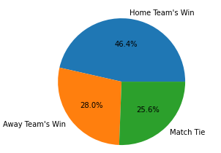

Figure 1.1: Wins of Home Team vs Away Team
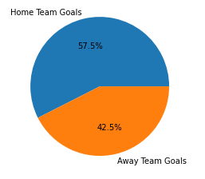

Figure 1.2: Goal Scored by Home Team vs Away Team

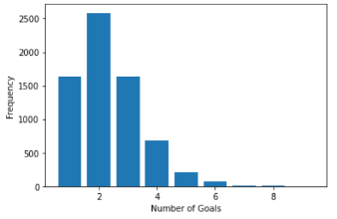
Figure 1.3: Goal Scored by Winning Team
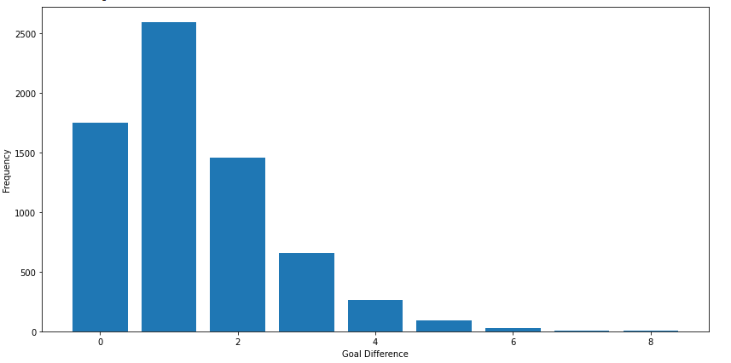
Figure 1.4: Difference in the goals scored by the teams in the matches
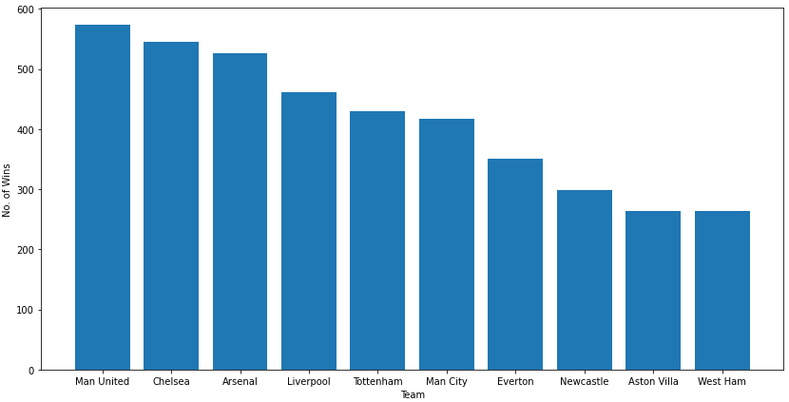
Figure 1.5: Top 10 teams with most wins
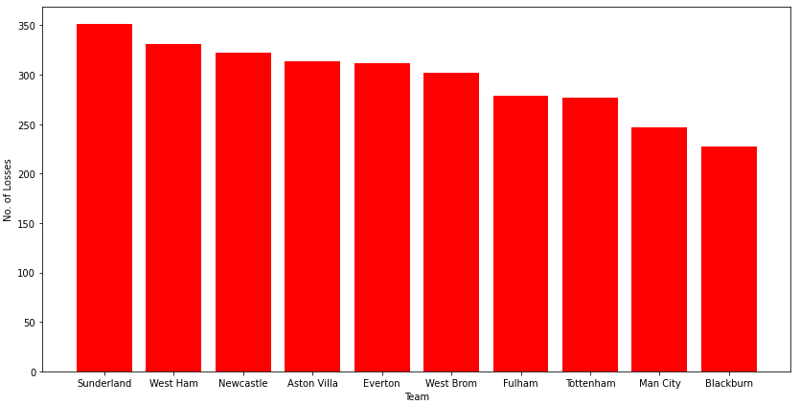
Figure 1.6: Top 10 teams with most losses

Conclusion

In this project, we aimed to predict the outcome of soccer matches using four different machine learning algorithms: SVM, logistic regression, random forest, and XGBoost. We evaluated the performance of each algorithm using various metrics such as accuracy, precision, recall, and f1-score.
Our results showed that all four methods, including SVM, logistic regression, random forest, and XGBoost, achieved high accuracy rates in predicting match outcomes. XGBoost outperformed the other algorithms, indicating its potential use in sports betting to increase the chances of winning. The logistic regression model achieved an accuracy of 65%, with a precision of 0.65 and recall of 0.73 for predicting NH outcomes. SVM, however, performed poorly with an accuracy rate of 54% due to its low recall for predicting H outcomes. The random forest model achieved an accuracy of 64%, with a precision of 0.65 and recall of 0.72 for predicting NH outcomes. After tuning the hyperparameters of XGBoost, its accuracy improved to 64%, with a precision of 0.64 and recall of 0.74 for predicting NH outcomes.
However, we also found that all four algorithms achieved relatively high accuracy rates, with logistic regression, random forest, and XGBoost achieving similar levels of accuracy. SVM, on the other hand, had a lower accuracy rate, indicating that it may not be the best algorithm to use for this task.
Overall, our results suggest that machine learning algorithms can be a powerful tool for predicting the outcomes of soccer matches, providing valuable insights for coaches and teams to improve their performance. The use of such algorithms in sports analytics has the potential to revolutionize the way we analyze and predict sports outcomes, leading to better decision-making and more accurate predictions.

Acknowledgment

References
[1] API Reference — Matplotlib 3.7.1 documentation. (n.d.). https://matplotlib.org/stable/api/index

[2] Baboota, R., & Kaur, H. (2019). Predictive analysis and modelling football results using machine learning approach for English Premier League. International Journal of Forecasting, 35(2), 741–755. https://doi.org/10.1016/j.ijforecast.2018.01.003

